**Supply Leftover Food To Poor**

**By**

**Grandhi Venkata Satya Sai Preetham**

**saipreetham_grandhi@srmap.edu.in**

**Abstract**

While food waste and insecurity often exist within the same communities, they provide an opportunity to solve both at once. Through this project, we will carry out intermediation between surplus food suppliers and the people. Local restaurants, grocery stores, and food producers will be partnered with to gather food that is good to eat but would otherwise be tossed out and redistributed it to less fortunate individuals and families. Our initiative will fight food waste while at the same time giving nutritious meals to those who are nutritionally challenged and do not have access to adequate food resources. We will establish an effective system of collection, storage, and distribution of food through volunteers and community organizations. This project will bring awareness regarding food wastage and stimulate community involvement in food insecurity. Ultimately, this would be a model that we would want to see replicated in others, thus creating a culture of sharing and support. Our project will help to build the gap between food wastage to supply food to the poor. the project aims to reduce the deaths of many people due to hunger.

## **Index**

1. Introduction 4

2. How to use Food connect 5

3. Conclusion 11

**Introduction**

The "**Supply Leftover Food to the Poor**" Salesforce project brings together two of the most critical human problems of our time: food waste and hunger. We are building a program aimed at supplying leftover food to poor people. With advanced capabilities, our initiative specializes in efficiently managing venues, tasks, volunteers, and drop-off points that ensure leftover food reaches underprivileged communities where it is needed most.

Our aptly named "**Food Connect**" project is designed to make sure that excess food from restaurants, events, and homes is taken in smoothly and redistributed within the whole cycle. We, with our prowess at data management in Salesforce and process automation capabilities, will follow food donations, coordinate volunteers' efforts in the process, and optimize delivery routes so no food goes to waste and no person stays hungry.

**Key Features of Food Connect:**

**Real-Time Tracking**: Monitor food donations and deliveries in real time to ensure timely redistribution.

**Volunteer Management**: Manage volunteer sign-ups, scheduling, and tasks efficiently to bring the greatest impact.

**Automated Notifications**: Automated notifications to donors, volunteers, and recipients of when food will be collected and delivered.

**Data Analytics**: Analytics to find trends, optimize routes, and drive improvements into the efficiency of the food redistribution process.

**Community Engagement:** Engage local businesses, organizations, and individuals in the community in the fight against hunger.

Our Mission:

Minimize food waste and alleviate hunger using a sustainable, efficient redistribution system. We bridge surplus food to those who need it to make a big difference in food security and community wellbeing.

**How to Use Food Connect**

Welcome to Food Connect! Here's an easy guide to get you up and running, and make the most of our app.

Getting Started

**1. Log In**

Open the App: Open the Food Connect App on your device.

Enter Credentials: Log in with your username and password. If you are new, click "Sign Up" to create a new account.

**2. Set Up Your Profile**

Settings: Log in and proceed to settings pertinent to your profile.

Provide Details: Fill in the personal or organizational details and preferences.

Manage Venues

**1. Adding a Venue**

Proceed to Venues: Access the "Venues" tab.

Click "New ": Add an venue name, address, contact information, and other details.

Save: Click "Save" to add the venue to your list.

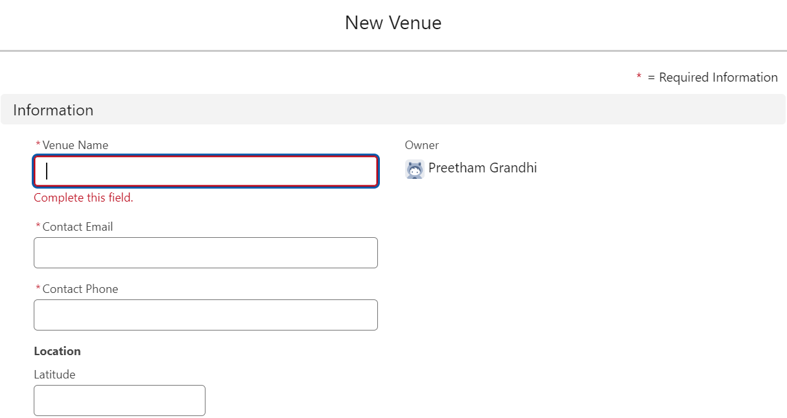

**2. Editing a Venue**

Choose Venue: Choose a venue from your previous list.

Venue Details: Modify the information related to the venue.

Save Changes: Click "Save" to save the information.

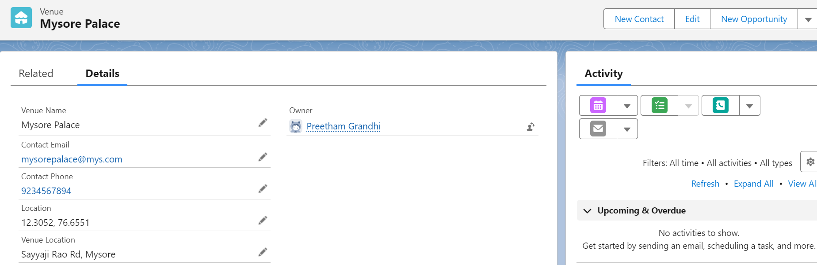

**Tasks Creation and Assignment**

**1. Task Creation**

View Tasks: Go to the "Tasks" area.

Create Task: Click "Nwe"; describe, assign a deadline and priority to the task.

Save: Click "Save" to create the task.

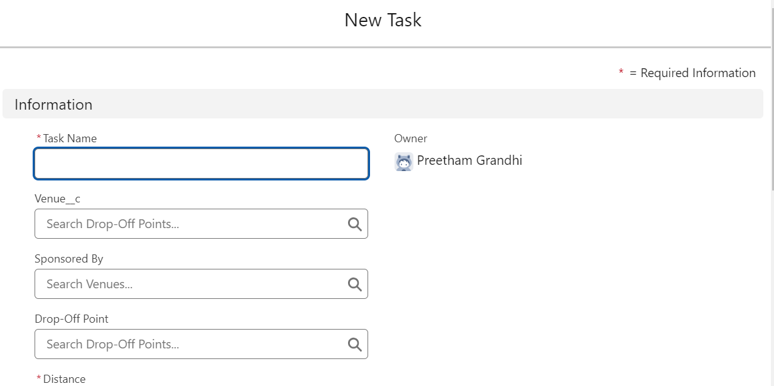

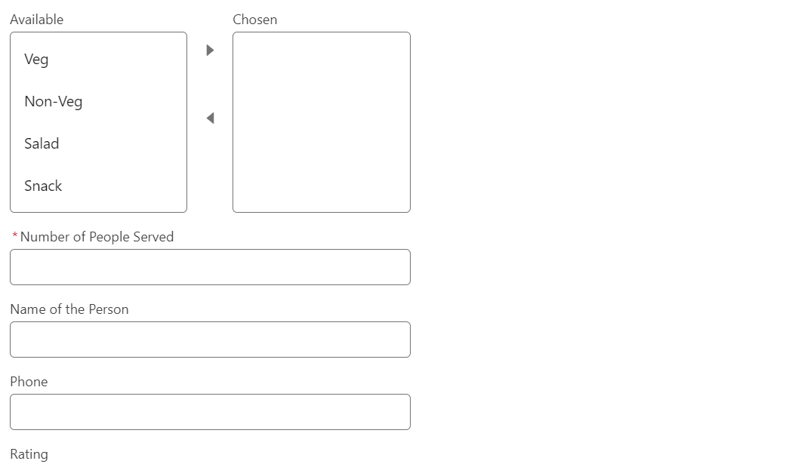

**Managing Drop-Off Points**

**1. Adding or Updating Drop-Off Points**

Drop-Off Points: Proceed to the "Drop-Off Points" area.

Add or Update: Enter drop-off point details .

Save Information: Click "Save."

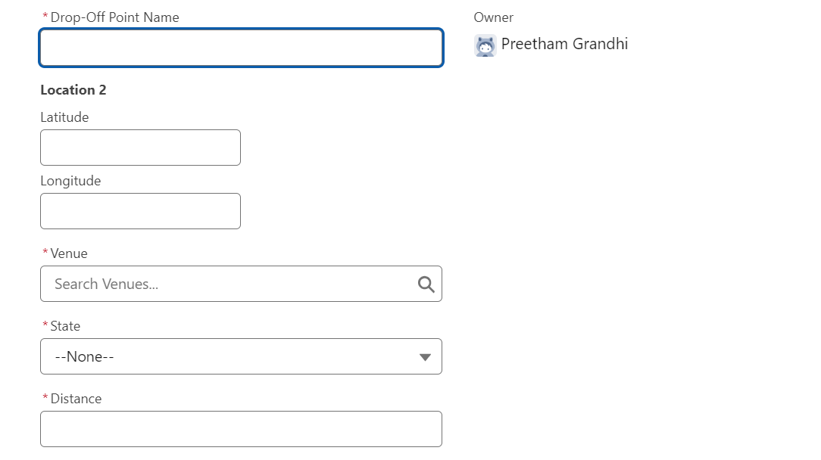

**Setting Up Execution Details**

**1. Event Planning**

Execution Details: Navigate to the "Execution Details" area.

Click "New ": Enter the details of the event, such as execution detail name, volunterr and task of the occurrence and details of logistics.

Save: Click "Save" .

**2. Coordinating the Activities**

Check Resources: Check if all resources are available and ready, such as volunteers or venues.

Detail Update: Update any details so that everything works out well.

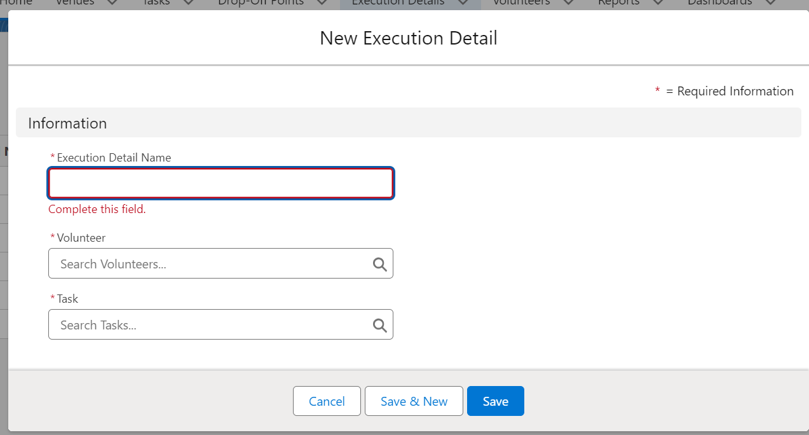

**Managing Volunteers**

**1. Adding Volunteers**

Go to Volunteers: Go to the "Volunteers" page.

Click "Newr"

Enter Details: Enter details of a volunteer along with his contact details and availability along with drop-off point.

Save: Click "Save" to add him to your list.

**2. Setting Roles**

Select Volunteer: Choose a volunteer from your list.

Task/Role: Record the volunteer task or role.

Save Assignment: Click "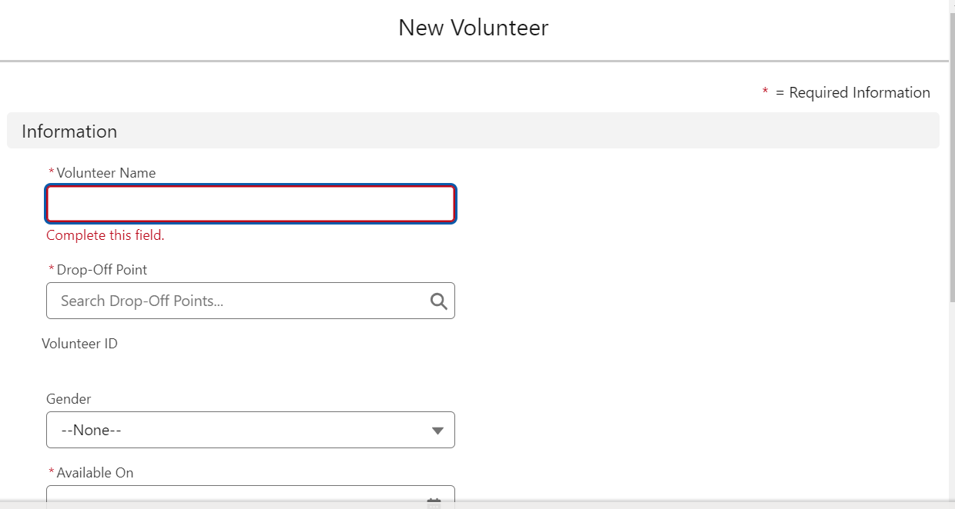Save" to complete the volunteer assignment.

**Reports Generation and Dashboard View**

**1. Reports Generation**

Reports: Navigate to the "Reports" page

It will show reports of the volunteers and also reports of the venue and drop off point.

**2. Dashboards View**

Dashboards: Navigate to the "Dashboards" page.

View Data: Interact with dynamic dashboards to view the activities in a summarized view.

Customise Views: In the dashboard settings, one can setup the dashboard to display metrics of importance.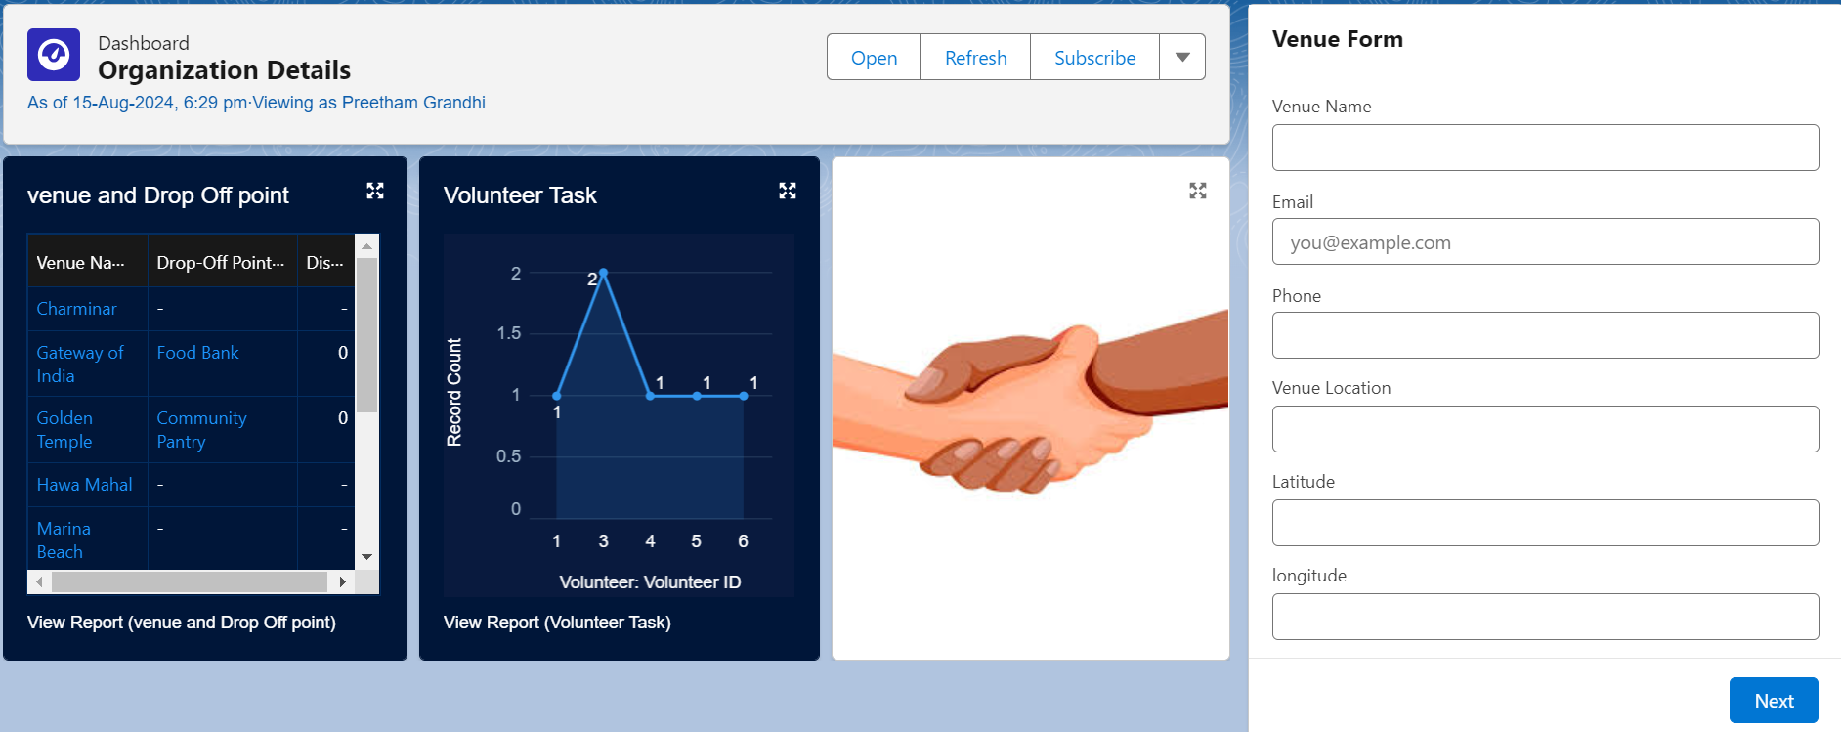

**Conclusion**

There project will not completely eradicate the hunger deaths. but, it will show a path to innovative minds to create there own way to eradicate the hunger death. the hunger death is the painful way to die. The hunger is root cause of crimes, if we make the country hunger free we can see a nation from developing to developed. It takes time. but, it will be possible with only innovative minds. Hunger not only gives pain also shows the inability of person to get food. don't waste food donate the food. Not only apps the public activeness will also help to donate the food. more awareness on the application and active participation of individuals will make the project success.